Motor Wiring Methods

In Canada, every province and territory adopts and enforces the same installation code, the Canadian Electrical Code (CEC), Part I, Electrical Installations. In particular, motor wiring is discussed in CEC, Rule Section 28.

In Alberta, Canadian Electrical Code, Part I (22th Edition), Safety Standard for Electrical Installations can be obtained from municipalaffairs.gov.ab.ca which would re-direct to an online Canadian Standards Association (CSA) web store.

In this portion of the course, we will look at how to determine copper conductor size, overcurrent and overload protection based on certain Rules from Rule Section 28.

We are going to examine the following four Rules:

Rule 28-104 Motor Supply Conductor Insulation Temperature Rating and Ampacity
Rule 28-106 Conductors, Individual Motors
Rule 28-200 Branch Circuit Overcurrent Protection
Rule 28-306 Rating or Trip Selection of Overload Devices

Rule 28-104
“28-104 Motor supply conductor insulation temperature rating and ampacity
- Supply conductors to a motor connection box shall have an insulation temperature rating equal to or greater than that required by Table 37, unless the motor is marked otherwise and their ampacity is based on a 75 °C conductor insulation rating except for Class A rated motors only, where their ampacity shall be permitted to be based on a 90 °C insulation rating, when 90 °C wire is used as circuit conductors to the motor.
- Where Table 37 requires insulation temperature ratings in excess of 75 °C, the motor supply conductors shall be not less than 1.2 m long and shall terminate in a location not less than 600 mm from any part of the motor except that for motors rated 100 hp or larger, their terminations shall be not less than 1.2 m from any part of the motor.
- For ambients higher than 30 °C, the supply conductor insulation rating shall be increased at least by the difference between the ambient and 30 °C.” (CSA Standards C22.1-12, Canadian Electical Code, Part I, Safety Standard for Electrical Installations, 22nd Edition)

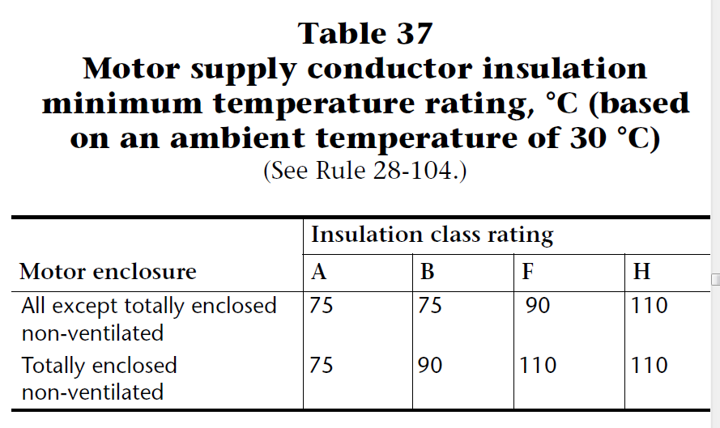

Rule 28-106

Once conductor temperature rating is determined, the minimum wire size can then be selected per Rule 28-106.

28-106 Conductors — Individual motors
- The conductors of a branch circuit supplying a motor for use on continuous duty service shall have an ampacity not less than 125% of the full load current rating of the motor.
- The conductors of a branch circuit supplying a motor for use on non-continuous duty service shall have an ampacity not less than the current value obtained by multiplying the full load current rating of the motor by the applicable percentage given in Table 27 for the duty involved, or for varying duty service where a deviation has been allowed in accordance with Rule 2-030 by a percentage less than that specified in Table 27.
- Tap conductors supplying individual motors from a single set of branch circuit overcurrent devices supplying two or more motors shall have an ampacity at least equal to that of the branch circuit conductors, except that where the tap conductors do not exceed 7.5 m in length, they shall be permitted to be sized in accordance with Subrule (1) or (2), provided that the ampacity so determined is not less than 1/3 of the ampacity of the branch circuit conductors.

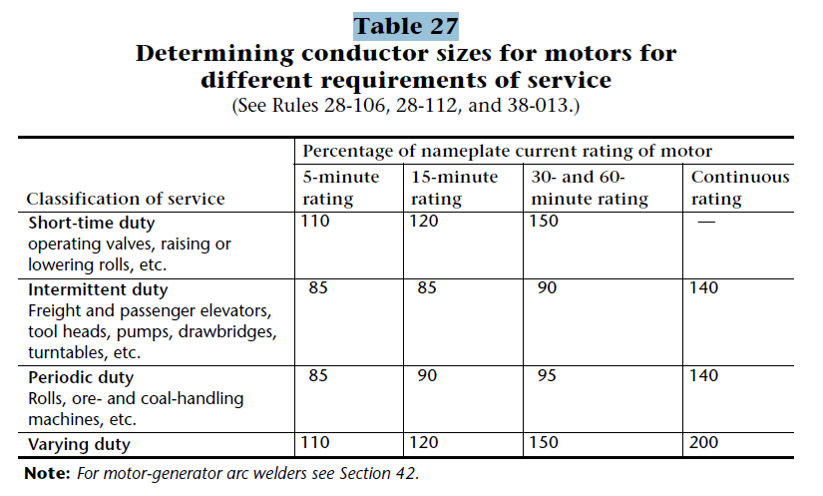
Rule 28-200
28-200 Branch circuit overcurrent protection
Each ungrounded conductor of a motor branch circuit shall be protected by an overcurrent device complying with the following:
- a branch circuit supplying a single motor shall be protected, except as permitted by Item (c), by using an overcurrent device of rating not to exceed the values in Table 29 using the rated full load current of the motor;
- notwithstanding Item (a), an overcurrent device having a minimum rating or setting of 15 A shall be permitted even though it exceeds the values specified in Table 29;
- instantaneous-trip (magnetic only) circuit interrupters shall be permitted where applied in accordance with Rule 28-210;
- where the overcurrent devices as determined in Item (a) will not permit the motor to start, the rating or setting of the overcurrent device shall be permitted to be increased as follows:
- a non-time-delay fuse:
  - not in excess of 400% of the motor full load current for fuses rated up to 600 A; or
  - not in excess of 300% of the motor full load current for fuses rated 601 to 6000 A;
- a time-delay fuse to a maximum of 225% of the motor full load current;
- an inverse time circuit breaker:
  - not in excess of 400% of the motor full load current for breakers rated up to 100 A; or
  - not in excess of 300% of the motor full load current for breakers rated greater than 100 A;
- where the overcurrent device is a thermal magnetic breaker that has separate instantaneous-trip settings, the instantaneous-trip setting shall not be greater than that specified in Rule 28-210; and
- for a branch circuit supplying two or more motors, the rating or setting of the overcurrent device shall not exceed the maximum value permitted by Rule 28-206.

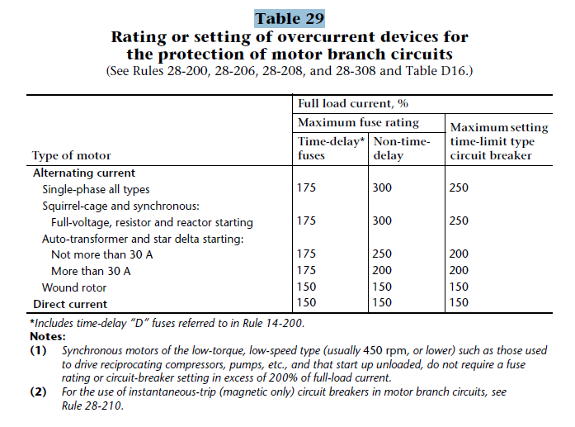

Rule 28-306

28-300 Overload protection required
The branch circuit conductors and control equipment of each motor shall have overload protection, except as permitted by Rule 28-308.
28-306 Rating or trip selection of overload devices (see Appendix B)
    - Overload devices responsive to motor current, if of the fixed type, shall be selected or rated or, if of the adjustable type, shall be set to trip at not more than the following:
      - 125% of the full load current rating of a motor having a marked service factor of 1.15 or greater; or
      - 115% of the full load current rating of a motor that does not have a marked service factor or where the marked service factor is less than 1.15.
    - Where a motor overload device is connected so that it does not carry the total current designated on the motor nameplate, such as for wye-delta starting, the percentage of motor nameplate current applying to the selection or setting of the overload device shall be clearly marked on the motor starter shown in the motor starter manufacturer’s overload selection table.

